Duty Roster For NHMP

ARSALAN AMJAD

NAVEED hUSSAIN

HINA BEGUM



DEPARTMENT OF COMPUTER SCIENCES

COMSATS UNIVERSITY ISLAMABAD

ATTOCK CAMPUS -PAKISTAN

SESSION 2019-2021

Duty Roster For NHMP

*Undertaken By:*

**ARSALAN AMJAD**

CIIT/sp19-mcs-001/ATK

**NAVEED HUSSAIN**

CIIT/sp19-mcs-013/ATK

**HINA BEGUM**

CIIT/FA18-mcs-033/ATK

*Supervised By:*

**ARMUGHAN ALI**

A DISSERTATION SUBMITTED AS A PARTIAL FULFILLMENT OF THE

REQUIREMENTS FOR THE DEGREE OF MCS

DEPARTMENT OF COMPUTER SCIENCES

COMSATS UNIVERSITY ISLAMABAD

ATTOCK CAMPUS -PAKISTAN

SESSION 2019-2021

UNDERTAKEN

We certify that this is my/our own work. The work has not, in whole or in part, been presented elsewhere for assessment. Where material has been used from other sources it has been properly acknowledged. If this statement is untrue, we acknowledge that we will have committed an assessment offence and shall be liable to punishable action under the plagiarism rules of HEC.

**______________ ____________________ ____________________**

Arsalan Amjad Hina Begum Naveed Hussain

sp19-mcs-001 FA18-mcs-033 sp19-mcs-013

Dated: _________ Dated: _________ Dated: _________

**Final Approval**

Certified that we have read this project report submitted by (Mr. Arsalan Amjad, Mr. Naveed Hussain & Miss Hina Begum) and it is, in our judgment, of sufficient standard to warrant its acceptance by Department of Computer Science, COMSATS University Islamabad, Attock Campus, for the Mcs degree.

***Committee:***

1. External Examiner ____________________________

(Examiner Name)

Designation

University Name

2. Supervisor ____________________________

(Supervisor Name)

Designation

3. Head of the Department ____________________________

**Dedication**

This thesis is dedicated to: The sake of Allah, my Creator and my Master, my great teacher and messenger, Muhammad (May Allah bless and grant him), who taught us the purpose of life. The Comsats University; my second magnificent home; my great parents, who never stop giving of themselves in countless ways, to all my Teachers & Family. My friends who encourage and support me, all the people in my life who touch my heart, I dedicate this research.

**ACKNOWLEDGEMENT**

In the name of Allah, the most merciful and most beneficial without whom nothing is possible. On the completion of our project, we are grateful to the Allah Almighty who provides us all the resources and health, so that we make its proper use for the benefit of mankind. May He keep providing us with all the resources and courage, and the guidance so that we keep helping humanity? We would like to thank few specific people who played a vital role in this whole process. First of all, we would like to thank our parents and friends whose encouraging words and constant support motivated us throughout this journey. In addition, they kept backing me up all the times, both financially and morally.

Moreover, we would also like to thank our supervisor Sir. Armughan Ali for his guidance and encouragement to work hard. We have found him very helpful while discussing the issues in the entire work. His critical comments on my work and continuous efforts that have certainly made me think of new ideas and techniques in the fields of optimization and software simulation.

**PROJECT BRIEF**

PROJECT NAME Duty Roster for NHMP

ORGANIZATION NAME National Highways and Motorway Police

OBJECTIVE To automate the process of duty roster in NHMP

UNDERTAKEN BY Arsalan Amjad (SP19-MCS-001)

Naveed Hussain (SP19-MCS-013)

Hina Begum (FA18-MCS-033)

SUPERVISED BY Mr. Armughan Ali

Assistant Professor

Computer Science

CUI Attock

Started On March-01-2020

Completed On December-05-2020

COMPUTER USED HP and Toshiba

SOURCE LANGUAGE Java and XML

OPERATING SYSTEM Windows 10

TOOLS USED Android Studio, Firebase Database, Star UML and

MS Office

**ABSTRACT**

This is the digital era, so most of the work is done digitally here and so must be the making of duty roster. All the automated activities have precision, accuracy, and robustness. The motto of National Highways and Motorway Police (NHMP) is friendly highways and that is possible if accidents are reduced and the free flow of traffic is ensured. To make duty officers vigilant, assignment of duty should be such that we get a vigilant officer on rush duty point and that is possible only if an officer is happy at that point, duties should be assigned as per the choices made by the officers. A manual duty roster may have errors in it; more than one duty could be initiated and SOP constraints could be violated etc. So to bypass all the errors of the manual creation of duty roster it is recommended to get it automatically because manual duty roster could be biased, difficult to make and time-consuming. To solve all these problems and make the construction of a duty roster more transparent and to achieve that we are proposing an Android-based application that will facilitate and help the NHMP officials. Managing duty roster using Android OS as it is easy, common and free to use and moreover officers of NHMP are well trained on running android devices as they are doing E-Ticketing for more than 4 years. We will be having some options where the user can give his preferences and choices to the system like preferred duty point, shift and other duty officer. It will make an interactive environment causing enhance professionalism. The system will assign duties as per the ratings made by supervisor admin, preferences made by the users and record from the E-ticketing data thus making a duty roster that would be transparent, accurate and attractive.

**Table of Contents**

1 Introduction 1

1.1 Proposed system 2

1.2 Solution of the problem 2

1.3 Features 3

1.4 Goals and Objective 3

1.5 Motivation and Scope 4

1.6 Benefits 4

1.7 Tools and Technologies 4

2 Literature review 6

2.1 Related applications 6

2.1.1 Plan: Roster plan for shifts 6

2.1.2 Plan my shift: duty roster 7

2.1.3 Roster maker 8

3 Requirements Specifications 11

3.1 Functional Requirements 11

3.1.1 Login 11

3.1.2 User registration 11

3.1.3 Logout 12

3.1.4 View duty roster 12

3.1.5 Log duty roster 12

3.1.6 View record 12

3.1.7 Set preferences/ choices 13

3.1.8 Leaves 13

3.1.9 Request leave 13

3.2 Non-Functional requirements 13

Properties 14

Reliability 14

Speed 14

Security 14

Performance 14

Portability 14

Complexity 14

Testability 14

Integrality 14

Robustness 14

Modifiability 14

Usability 14

Efficiency 14

Scalability 14

Availability 14

Maintainability 14

4 Project Design 16

4.1 Officer Use Case Diagram 16

4.2 Admin Use Case Diagram 17

4.3 Officer Activity Diagram 17

4.4 Admin Activity Diagram 18

4.5 Class diagram 20

5 Implementation 22

5.1 Tools & Technologies 22

5.2 Screenshot of Application 22

5.2.1 Splash Screen 22

5.2.2 Main Activity Screen 23

5.2.3 Login Screen 23

5.2.4 Admin Dashboard 24

5.2.5 List User 25

5.2.6 Add officers 25

5.2.7 View leave request 26

5.2.8 View Roster History 27

5.2.9 Add Rating 27

5.2.10 Profile Screen 28

5.2.11 Order list 29

5.2.12 Duty Roster 30

5.2.13 View Duty Roster 30

5.2.14 Officer Dashboard 31

5.2.15 Set Choices 31

5.2.16 Leaves 33

5.2.17 Drawer List 33

5.2.18 Forgot Password 34

5.2.19 Leave request 34

5.2.20 View Duty Roster 35

6 Evaluation 37

6.1 Testing 37

6.2 Basic Foundation of Testing 37

6.2.1 Black Box Testing 37

6.2.2 White Box Testing 37

6.3 Types of Testing 37

6.3.1 Unit Testing 37

6.3.2 Integration Testing 38

6.3.3 System Testing 38

6.4 Test Cases 38

6.4.1 Login Testing 38

6.4.2 Forgot Password Testing 39

6.4.3 Add Officer Testing 39

6.4.4 Add Rating testing 40

6.4.5 Set Choices testing 40

6.4.6 Add leave request testing 41

6.4.7 Logout Testing 41

7 Conclusion 41

7.1 Future work 41

7.2 References 41

**Table of Figures**

Figure 2. 1 PLAN: roster plan for shifts 6

Figure 2. 2 Plan my shift: duty roster 7

Figure 2. 3 Roster maker 8

Figure 4. 1 officer Use case diagram 16

Figure 4. 2 Admin Use case 17

Figure 4. 3 Activity digram officer 18

Figure 4. 4 Activity diagram admin 19

Figure 4. 5 class diaGram 20

Figure 5. 1 splash screen 22

Figure 5. 2 Main Activity screen 23

Figure 5. 3 login screen 24

Figure 5. 4 admin dashboard 24

Figure 5. 5 List User 25

Figure 5. 6 Add officer 26

Figure 5. 7 View leave request 26

Figure 5. 8 view roster history 27

Figure 5. 9 add rating 28

Figure 5. 10 profile screen 28

Figure 5. 11 Create order 29

Figure 5. 12 order list 29

Figure 5. 13 duty roster 30

Figure 5. 14 view duty roster 30

Figure 5. 15 officer dashboard 31

Figure 5. 16 set choices A 32

Figure 5. 17 set choices b 32

Figure 5. 18 leaveS 33

Figure 5. 19 drawer list 34

Figure 5. 20 Forgot password 34

Figure 5. 21 Leave request 35

Figure 5. 22 view duty roster 35

**Table of tables**

Table 2. 1 ComParison table 9

Table 3. 1 Login 11

Table 3. 2 user registration 11

Table 3. 3 logout 12

Table 3. 4 View duty roster 12

Table 3. 5 Log duty roster 12

Table 3. 6 view record 12

Table 3. 7 set preferences / choice 13

Table 3. 8 leaveS 13

Table 3. 9 request leave 13

Table 3. 10 NFRS 14

Table 6. 1 logout testing 38

Table 6. 2 forgot password testing 39

Table 6. 3 add ofiicer testing 39

Table 6. 4 add rating testing 40

Table 6. 5 Set choices testing 40

Table 6. 6 Add leave request testing 41

Table 6. 7 Logout testing 41

**Chapter 1**

**Introduction**

# 1 Introduction

Duty assignment plays a key role in creating a vigilant team that would perform ideally and NHMP officials work hard to perform really well on the National highways and the Motorways in Pakistan. We need a field formation for such a basic building block so that officers of NHMP perform well, assist the road users and punish the violators strictly. Human work leads to some errors that could be tackled by an automated system. Besides human errors, a manual system has a level of biasness in it. Moreover, it's slow and it’s difficult to remember all the constraints that are applied. The admin officer is responsible for the duty management and assignment in NHMP. Officers (users) will get an interface where they can have an option like duty shift, area, and a list of friend officer. There would be a set of ratings made by the supervisor admin. These ratings will be based on the previous record like punctuality and behavior with seniors etc. The supervisor admin (Admin officer) can also deduct the ratings due to any misconduct that will affect his score (rating) negatively. E-ticketing data will make another set of the score for the officer. Some are quality tickets having high scores, both quality and quantity of tickets combined together will create a score (rating). Special achievements like commendation certificates from senior commands and good work will have extra points in it. Helps made by the officer will have different scores (rating). Combining all these the system will set a priority level that will decide the duty of any officer (shift, area, and friend officer). For all that, we are proposing and Android-based application as it’s a good option to pursue with because it's easy to use, popular and free. Officers can also request for leave that depends on the subject to the approval from DSP/CPO. An officer can know about his upcoming monthly rest. Every officer can check his performance hence raising an urge in improvement for things like professional behavior, E-ticketing quality and help standard. Concluding it, all the users (officers) can set their preferences with just a few clicks and all the cons of the manual system will be reduced while working in such an interactive and transparent system.

## Proposed system

The motto of National Highways and Motorway Police (NHMP) is friendly highways and that is possible if accidents are reduced and the free flow of traffic is ensured. To make duty officers vigilant, assignment of duty should be such that we get a vigilant officer on rush duty point and that is possible only if an officer is happy at that point, duties should be assigned as per the choices made by the officers. The problems in manual assignment of duty roster could be solved only if it’s made automatic.

A manual system may have the following drawbacks:

* It’s time consuming
* It lacks transparency
* Manual duty roster could be biased
* It may have errors in it
* More than one duty could be initiated & SOP constraints could be violated etc.

## Solution of the problem

To resolve the problems associated to the manual system of duty roster we are going to design an android application named “Duty Roster for NHMP”. We are using a firebase database, which store all data for this project and provide an efficient way to store and retrieve data. This application will be helpful for the users and add will be helpful for officers to give their preferences and they will have a transparent format for their acceptance. The proposed system will computerize the whole process of duty roster using this application. The system will assign duties as per the ratings made by supervisor admin, record from the E-ticketing data and preferences made by the users thus making a duty roster that would be transparent, accurate and attractive.

## 1.3 Features

* User can request for choices from android phone.
* User can request for the suitable duty point, duty shift.
* User can view all information about him.
* User can get updates about duty roster instantly.
* Admin can add new user.
* Admin can delete the record.
* Admin can update the record.
* User can request leaves and the acceptance is authorized to DSP/CPO.
* Every user can check his performance hence raising an urge for its improvement.
* Users (officers) can set their preferences with just a few clicks.

## 1.4 Goals and Objective

* By developing this application, we want to replace the manual system of duty roster to an automated one.
* Saving the manual effort by making an automated system.
* Transparency in the process of duty roster and reducing human business.
* Create an alert and vigilant field formation.
* Remove human errors and create flexibility in the system.
* Attractive interface for the choice of duty.
* Acknowledgment for the upcoming monthly leave.
* Check real-time field formation.
* Build and observe the rating sense in officers.
* There would be an urge to improve:
* Professional behavior.
* E-ticketing.
* Helps.

## 1.5 Motivation and Scope

* Every manual activity is prone to have errors in it.
* Manual system to make an automatic one.
* Duty will be assigned on the basis of past performance, achievement and qualities.
* Reduction of errors and biasness from the system.
* It would be time-saving as the system will generate the roster in just a few clicks.
* Personal preferences will be provided by users.
* Combined ratings will be summed up and priorities will be given to high rated officers for the assignment of his preferred duty.

## 1.6 Benefits

* It’s a time saving process.
* Easy to find their shift area and second officers.
* The automated system will save time.
* It provides us proper coordination and management of officers
* Users (officers) can set their preferences with just a few clicks and all the cons of the manual system will be reduced while working in such an interactive and transparent system.
* Every user can check his performance hence raising an urge in improvement for things like professional behavior, E-ticketing quality and helps done.

## 1.7 Tools and Technologies

* Android Studio & SDK ( designing and development )
* Java programming language ( Building block of Application development )
* Firebase ( database )
* Star UML & Visual paradigm ( For designing of Diagrams )
* Microsoft Word (for documentation )
* Microsoft PowerPoint (for presentation )

**Chapter 2**

**Literature review**

# Literature review

There are many such popular android applications used around the globe by different departments but there is no application that is used to manage duty roster for any particular department. There are some apps that are used to manage duty roster and manage shifts but that is not suitable for the domain of NHMP. So there must be a specific application that is suitable for NHMP. These apps vary in their features and details according to their use and region. In our application we have added few new functionalities which are not in other existing apps.

## 2.1 Related applications

Brief review of a few existing apps used in different places of the world.

### Plan: Roster plan for shifts

Plan: Roster plan for shift is your one-stop solution for managing your roster. Keep up to date with changes made by your whole team or show only shifts assigned to you. It manages your absences based on absence types, create absences and maintain an overview of already created absences.

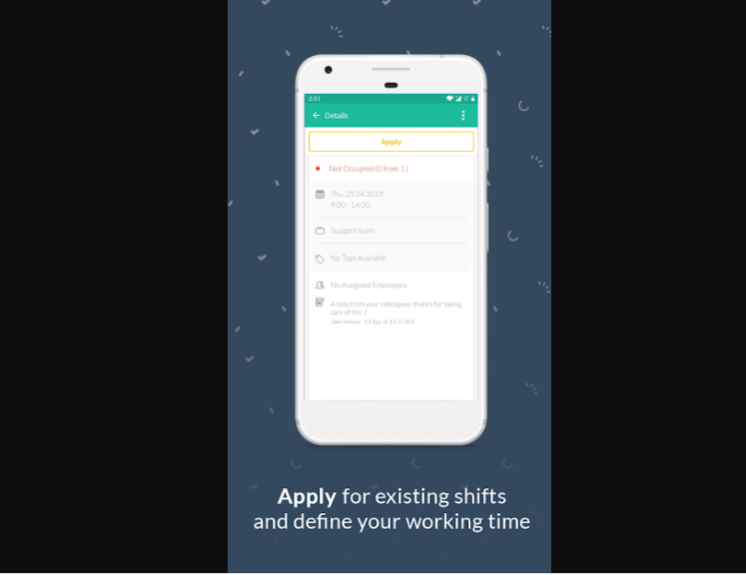 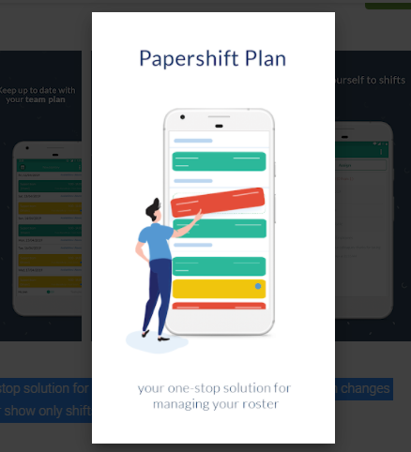

Figure 2. 1 PLAN: roster plan for shifts

It provides services such as:

* See your posters
* See your team roster
* Apply for shifts
* Assign yourself to shifts

Its weaknesses are:

* Time consuming

### Plan my shift: duty roster

Plan My Shift is a duty roster, shift calendar, shift planner designed for shift workers to help them manage their shifts easily. The focus of this shift calendar / shift planner is to simplify the generation and the maintenance of a shift schedule or duty roster. There are two odes: Edit Mode and Lock Mode in the Edit Mode.

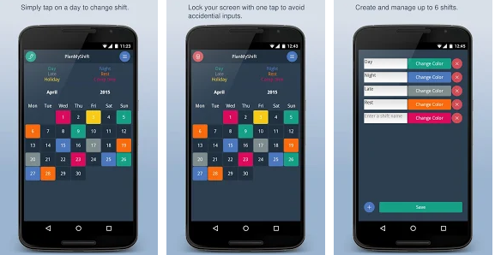

Figure 2. 2 Plan my shift: duty roster

Its services are:

* It’s easy and simple to use
* Change shift and keep tracks quickly
* User interactive

Its weaknesses are:

* No backup and restore

### Roster maker

This application was developed by a youth soccer team coach/manager. The intent was to create and application that can quickly generate/regenerate player lineups and rosters. While the original intent was for soccer, it can easily be adapted to be used for any sports that has a setup of Forward/Midfield/Defense/Goalie (or even can be used without anyone in those positions).  
You can make generate roster automatically. The application will make a perfect roster with players never repeating positions and it balances all players. Even if the roster that it generates is not ideal, the roster can be edited with a drag and drop interface.

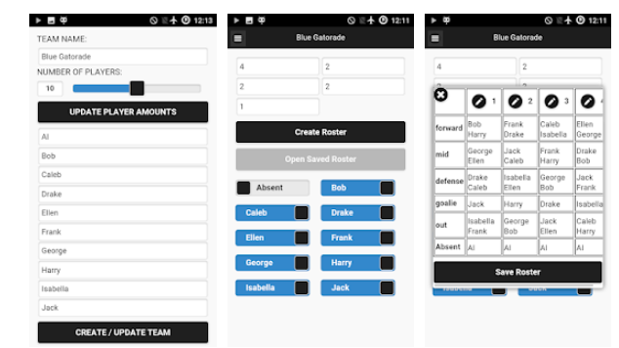

Figure 2. 3 Roster maker

Its services are:

* Simple and easy to use
* Roster can be edit by drag and drop
* Application will generate a mass text or email to all player’s parents.

Its weaknesses are:

* Time consuming
* Less speed

Table 2. 1 ComParison table

|  |  |  |  |  |
| --- | --- | --- | --- | --- |
| **Features** | **Plan: Roster Plan For Shifts** | **Plan my shift: duty roster** | **Roster maker** | **Duty Roster for NHMP** |
| Specific for department | No | No | No | Yes |
|  |  |  |  |  |
| Priority based assignment | No | No | No | Yes |
|  |  |  |  |  |
| User interactive | Yes | Yes | Yes | Yes |
|  |  |  |  |  |
| View previous record | No | Yes | Yes | Yes |
|  |  |  |  |  |
| Duty manage | Yes | Yes | Yes | Yes |
| Set preferences /choice | No | No | No | Yes |

**Chapter 3**

**Requirement Specifications**

# Requirements Specifications

System Requirements Specification (SRS) is a formal statement of the application functional and operational requirements. It serves as a contract between the developer and the customer for whom the system is being developed. The developers agree to provide the capabilities specified. The software requirements specification enlists enough and necessary requirements that are required for the project development.

## 3.1 Functional Requirements

Functional requirements explain the features and functions of the app and the expected behavior of the app. In software development and system engineering, the functional specification is a document that spells out the functions a system or component must perform.

### 3.1.1 Login

Table 3. 1 Login

|  |  |
| --- | --- |
| Requirement id | 1 |
| Description | The system will provide login functionality to the user with an e-mail and password. |
| Dependencies | Internet connection |

### 

### 3.1.2 User registration

Table 3. 2 user registration

|  |  |
| --- | --- |
| Requirement id | 2 |
| Description | Admin Officer will add user in the system with temporary password (changeable password) |
| Dependencies | Internet connection |

### 3.1.3 Logout

Table 3. 3 logout

|  |  |
| --- | --- |
| Requirement id | 3 |
| Description | System provides a logout functionality to users. Users should be able to successfully logout at any given time from the system. |
| Dependencies | User must be logged into the system. |

### 

### 3.1.4 View duty roster

Table 3. 4 View duty roster

|  |  |
| --- | --- |
| Requirement id | 4 |
| Description | Admin officer and officer can view duty roster and admin can edit duty roster as per the requirements from the high ups. |
| Dependencies | Login must |

### 

### 3.1.5 Log duty roster

Table 3. 5 Log duty roster

|  |  |
| --- | --- |
| Requirement id | 5 |
| Description | We can see duty roster in specific date in the system. |
| Dependencies | User must logged in to his module |

### 

### 3.1.6 View record

Table 3. 6 view record

|  |  |
| --- | --- |
| Requirement id | 6 |
| Description | Officer can view his data or record and admin officer can view record of all users. |
| Dependencies | Internet connection , logged in |

### 

### 3.1.7 Set preferences/ choices

Table 3. 7 set preferences / choice

|  |  |
| --- | --- |
| Requirement id | 7 |
| Description | Officer can set preferences from his dashboard and can set choices like duty point, duty time, and friend officer (if applied). |
| Dependencies | User must logged into the system |

### 

### 3.1.8 Leaves

Table 3. 8 leaveS

|  |  |
| --- | --- |
| Requirement id | 8 |
| Description | Officer will click on Leaves, it will show all the leaves record. |
| Dependencies | Must internet connection, logged in. |

### 

### 3.1.9 Request leave

Table 3. 9 request leave

|  |  |
| --- | --- |
| Requirement id | 9 |
| Description | Officer will request for leave and admin have authority to approve it. |
| Dependencies | Must logged into system/modules |

## 3.2 Non-Functional requirements

Non-Functional requirement is any requirement that specifies how the system performs a certain function. In other words, a non-functional requirement will describe how a system should behave and what limits there are on its functionality. On functional requirements generally specify the systems quality attributes or characteristics. The following are some non-functional requirements of our application efficiency.

Table 3. 10 NFRS

|  |  |
| --- | --- |
| Properties | **Measures** |
| Reliability | This system is more reliable that properly performs function at the given time and respond in the expected way.  The application will meet the entire functional requirement without any unexpected behavior.  This system is more reliable that properly performs function at the given time and respond in the expected way.  The application will meet the entire functional requirement without any unexpected behavior. |
| Speed | This system will not robust and not lag or crash |
| Security | User data integrity should not be at stake.  Records should not be compromised and manipulated. |
| Performance | Fast Response time  high Throughput (number of operations performed per second) |
| Portability | Application runs on any device. |
| Complexity | This application is simple and all modules should avoid unwanted dependencies. |
| Testability | Ease of learning |
| Integrality | All components well integrated and complement each other. |
| Robustness | In the presence of faults, stress and invalid inputs |
| Modifiability | Provision in system for future addition of new functionalities |
| Usability | Effort require to learn, use, provide, input and interrupt result of the program |
| Efficiency | Minimal use of resources (disk, network, memory and processor) |
| Scalability | For large number of user or quantities of data |
| Availability | This application will available all time on the user android device |
| Maintainability | This application can maintained easily |

**Chapter 4**

**Project Design**

# Project Design

UML is an acronym that stands for **Unified Modeling Language**. Simply put, UML is a modern approach to modeling and documenting software. In fact, it’s one of the most popular [business process modeling techniques](http://tallyfy.com/business-process-modeling-techniques). It is based on **diagrammatic representations** of software components. As the old proverb says: “a picture is worth a thousand words”. By using visual representations, we are able to better understand possible flaws or errors in software or business processes. So, in this chapter we add officer & admin use case diagrams, officer & Admin activity diagrams and at last class diagram of whole project.

## Officer Use Case Diagram

In this application we have two main modules one is officersand the second one isadmin module. In this diagram we have module is on right side of the diagram & their functionalities which they can perform are, in the box like officer can login, view duty roster, set duty preferences, request leave, reset password, view roster history and the logout.

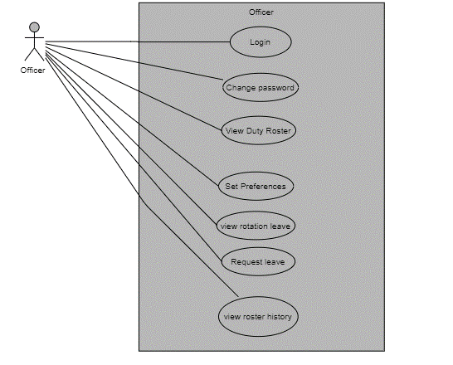

Figure 4. 1 officer Use case diagram

## Admin Use Case Diagram

Admin canlogin, reset password, view leave request, view roster history, add score rating and add E ticketing score in the use case diagram extend arrow always generate from derived class to base class which means that one functionality have further more functionalities why we generate include arrow from the login functionality (base class).

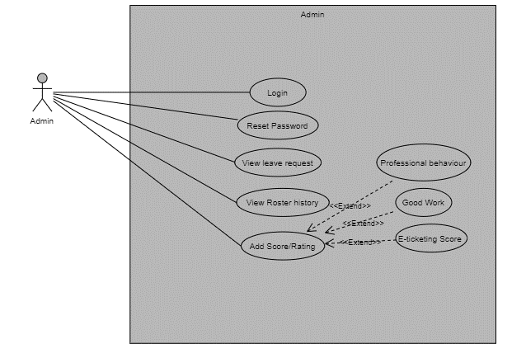

Figure 4. 2 Admin Use case

## Officer Activity Diagram

Figure 4.2 show the activity diagram of an officer. Firstly, officer will have logged into the system if he successfully login to the application he will perform his/her activities otherwise warning email will generate. After successfully login admin can set preferences, view duty roster, view request leave, view history and view leave. After performing these activities officer can have logged out from the system.

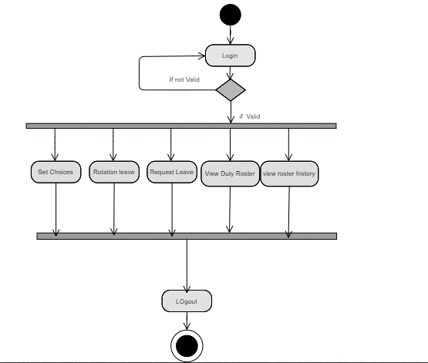

Figure 4. 3 Activity digram officer

## Admin Activity Diagram

Figure 4.4 show the activity diagram of an admin. Firstly admin will log into the system if he successfully login to the application he will perform his activities otherwise warning him to enter correct login credentials generate. After successfully login admin can add users, view list user, view request leave, view history and view duty roster. After performing these activities admin can log out from the system.

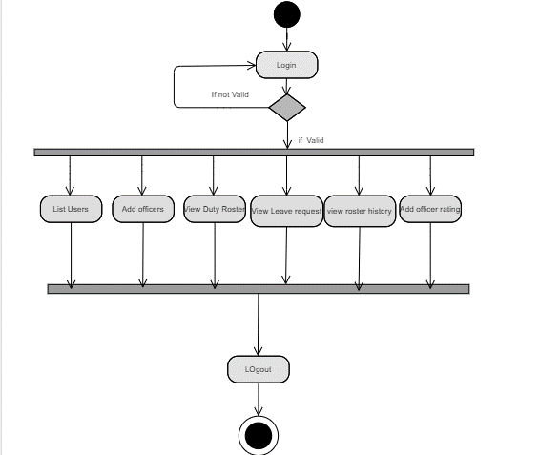

Figure 4. 4 Activity diagram admin

## Class diagram

Figure 4.5 shows the classes and relationships between class’s user, officer, duty, duty Time, duty roster & admin officers. The relationship between different classes displays in figure.

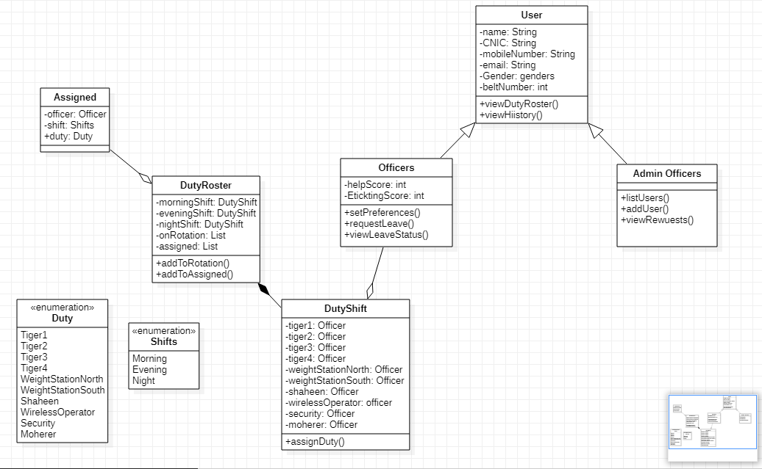

Figure 4. 5 class diaGram

**Chapter 5**

**Implementation**

# Implementation

Implementation of database and GUI interface is described in this section. How this section is implemented and how the interfaces look like is describe below in this section.

## Tools & Technologies

* Android studio
* Firebase
* SDK

## Screenshot of Application

There are the screenshots of application in the following.

### Splash Screen

Figure 5.1 shows the first screen of an app. This screen is called” Splash Screen”. When we run the application, we see splash screen for few seconds and then move to the next main activity screen.



Figure 5. 1 splash screen

### Main Activity Screen

Figure 5.2 shows the main activity screen of an application. Where users can select their own consoles and perform their activities.

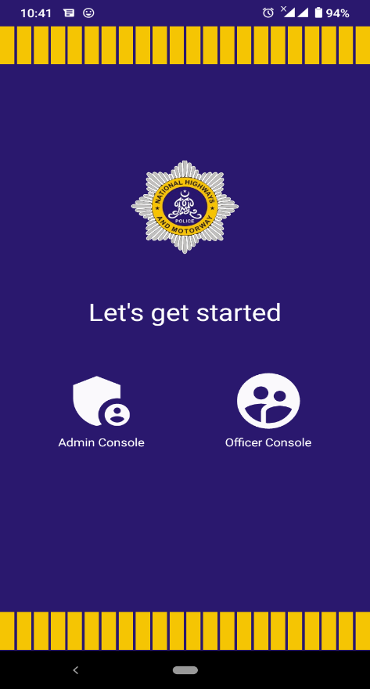

Figure 5. 2 Main Activity screen

### Login Screen

Figure 5.3 shows the login screen of an application. In login screen user will have enter their password or e mail. Login is available for all modules. User will remain login until she/he doesn’t logout.

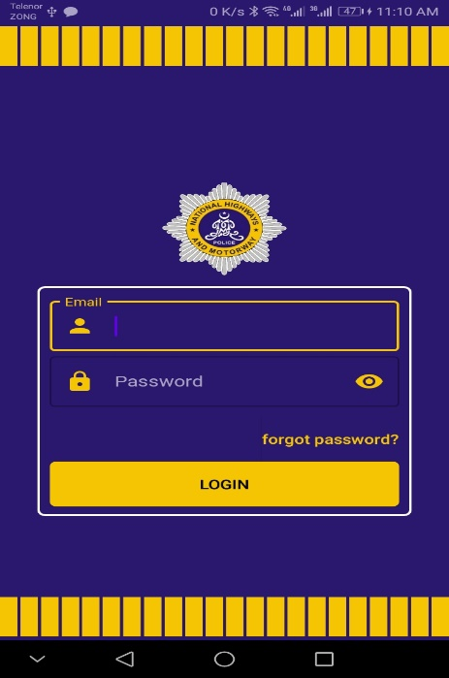

Figure 5. 3 login screen

### Admin Dashboard

Figure 5.4 shows the main admin dashboard of an application. After successfully login admin can easily perform his activities like Add officers, list users, view duty roster, view request, view history & add officer rating.

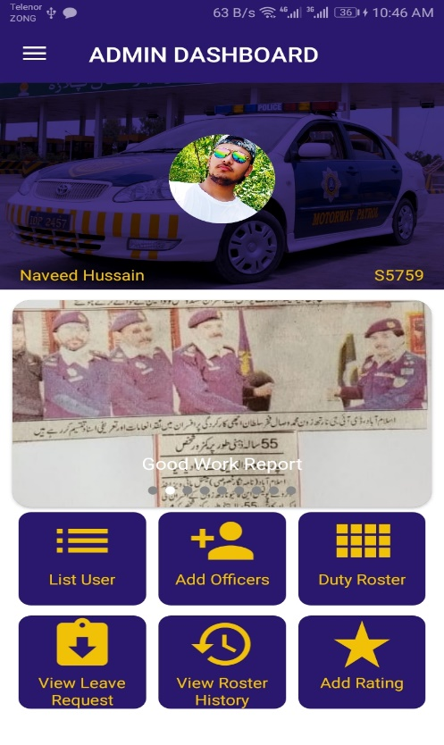

Figure 5. 4 admin dashboard

### List User

Figure 5.5 shows the officer list in an application. Where admin officers can view details of officers. In case of any change click on edit and delete any officer which is already added in this application by “delete” button.

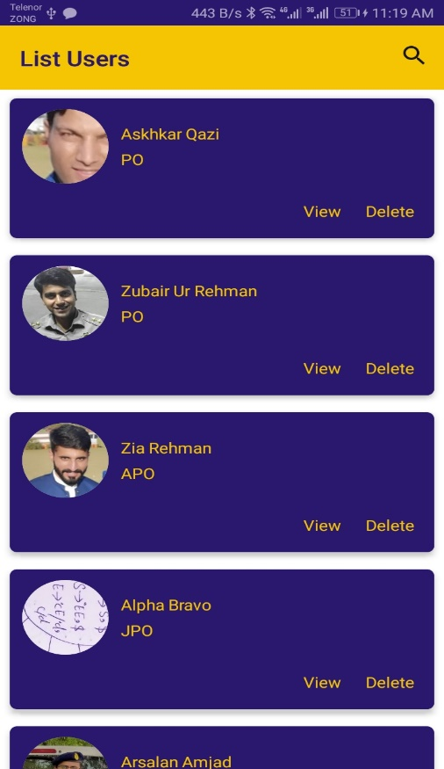

Figure 5. 5 List User

### Add officers

Figure 5.6 shows the add officers screen. Add New officers by entering their details like name, id, CNIC, phone number and address. Add officer means registration of newly transferred officer.

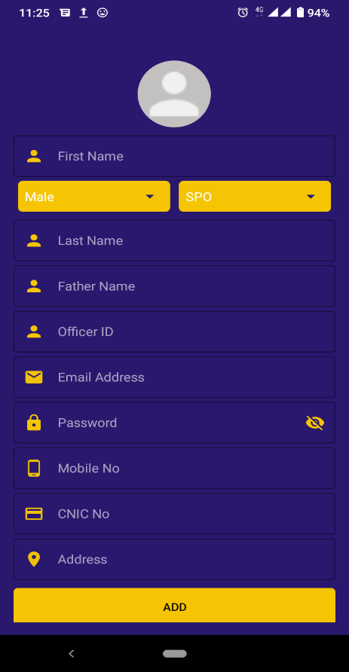

Figure 5. 6 Add officer

### View leave request

Admin officer will view the leave requests that are requested by officers those will be either approve or disapprove and check the previous record from RECENTS button.

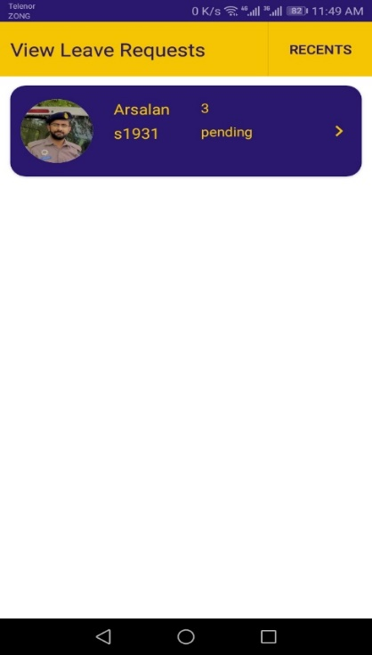

Figure 5. 7 View leave request

### View Roster History

Figure 5.8 shows the view roster history. Admin can see all the previous duty roster that are displayed in the form of cards.

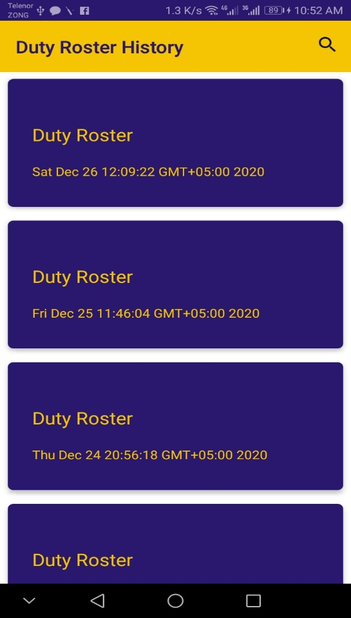

Figure 5. 8 view roster history

### Add Rating

Figure 5.9 shows the add rating for particular officers. In professional behavior admin can deduct or add points for any officer and can also add the E-ticketing score then submit the score and the score will be used for algorithm in creation of duty roster.

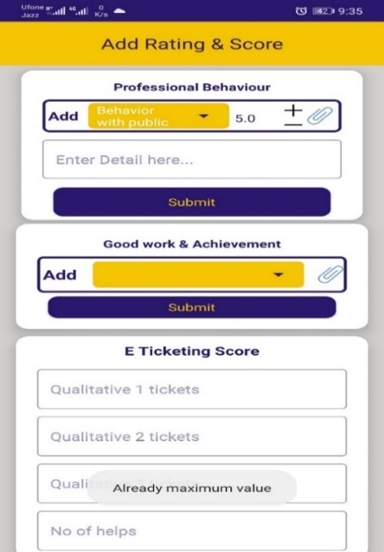

Figure 5. 9 add rating

### Profile Screen

Figure 5.10 shows the profile screen. Where admin can view the details about his profile.

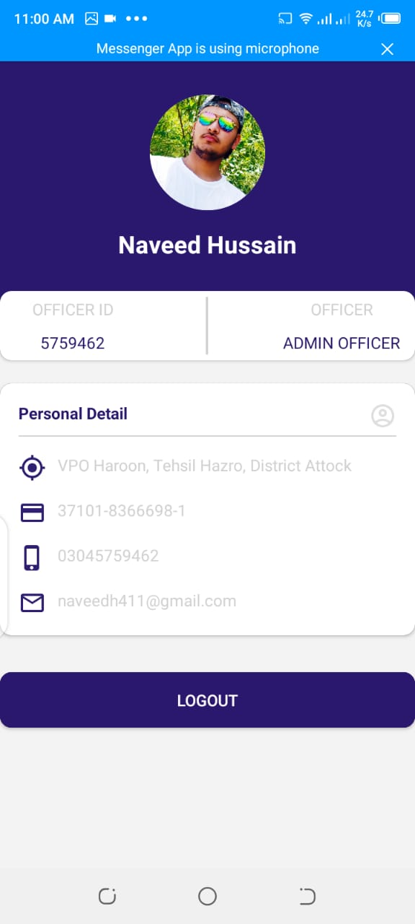

Figure 5. 10 profile screen

### Order list

Admin can add orders that will be displayed to all officers. There is an option to delete them as well.

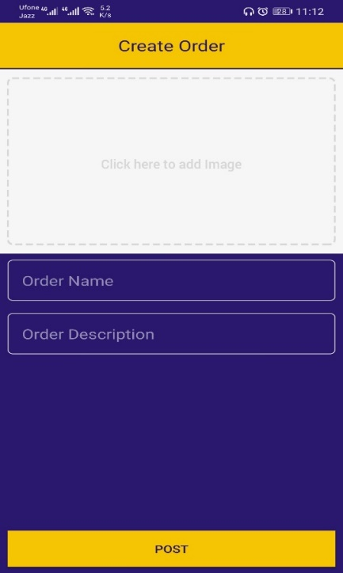

Figure 5. 11 Create order

An order title is required along with picture and the detail, all these orders are presented here.

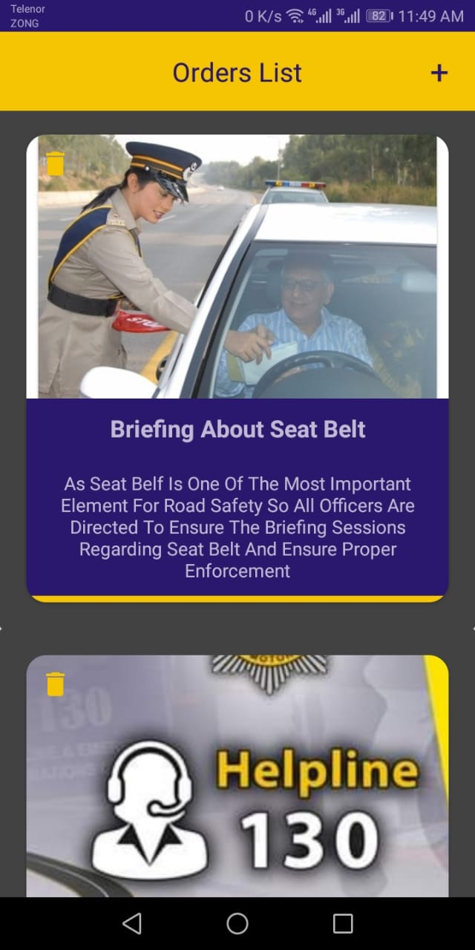

Figure 5. 12 order list

### Duty Roster

Figure 5.13 shows the duty roster screen. The duty roster option appears to both admin and officer and they can view duty roster. The generate duty roster will run and algorithm hence assigning new duties

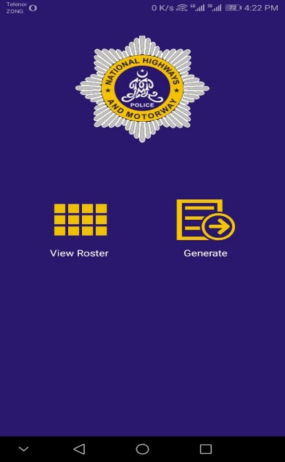

Figure 5. 13 duty roster

### View Duty Roster

Figure 5.14 shows the view duty roster screen when clicked on view duty roster. There is a search option where a user can search for his duties.

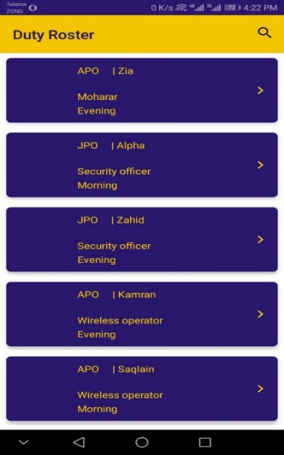

Figure 5. 14 view duty roster

### Officer Dashboard

Figure 5.15 shows the officer’s dashboard. Where officer can access his/her module and activities like set choices, rotation leave, view duty roster, request leave and view roster history.

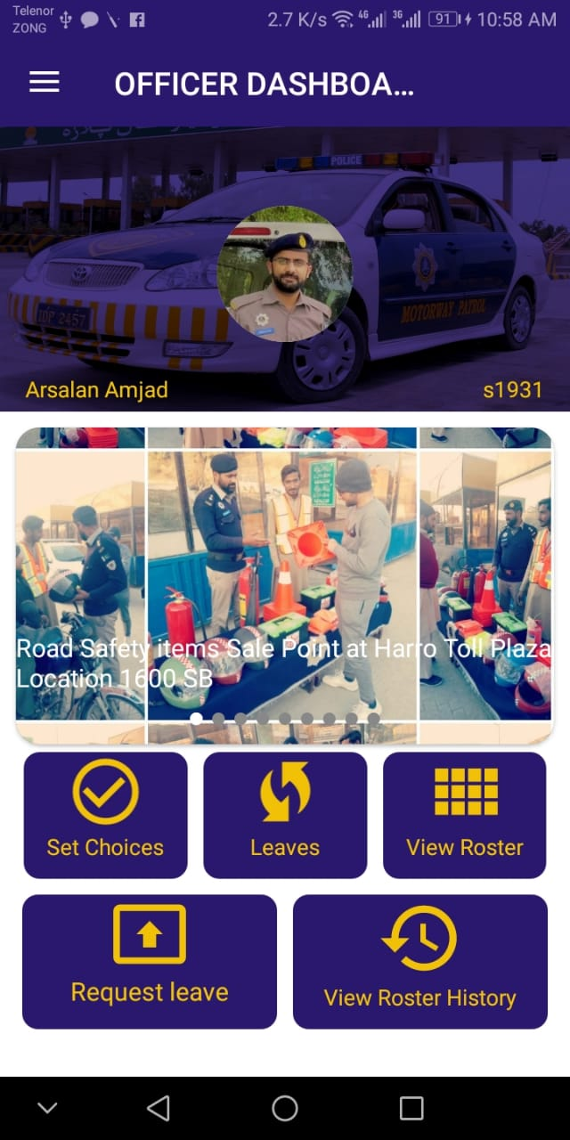

Figure 5. 15 officer dashboard

### Set Choices

Figure 5.16 shows the set choices screen A. In set choices A, APO’s & JPO’s can set choices only. They can make choice of duty point for moharar, wireless operator, security officer and submit to the database. Algorithm based on these set choice which officer make in this application.

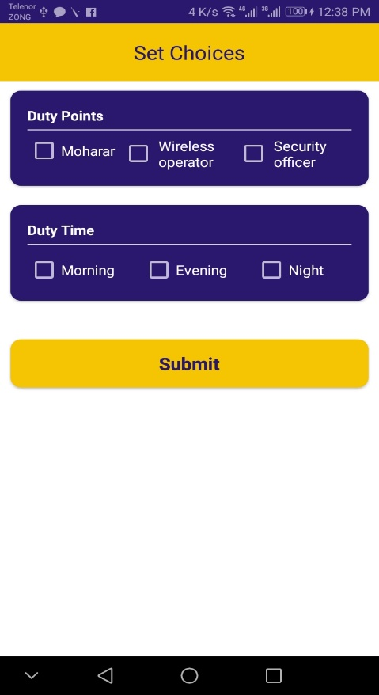

Figure 5. 16 set choices A

Figure 5.17 shows the set choices screen B. In set choices B, SPO’s & PO’s can set choices only. They can make choice of duty point, duty time and duty officers and submit to the database. Algorithm based on these set choice which officer make in this application.

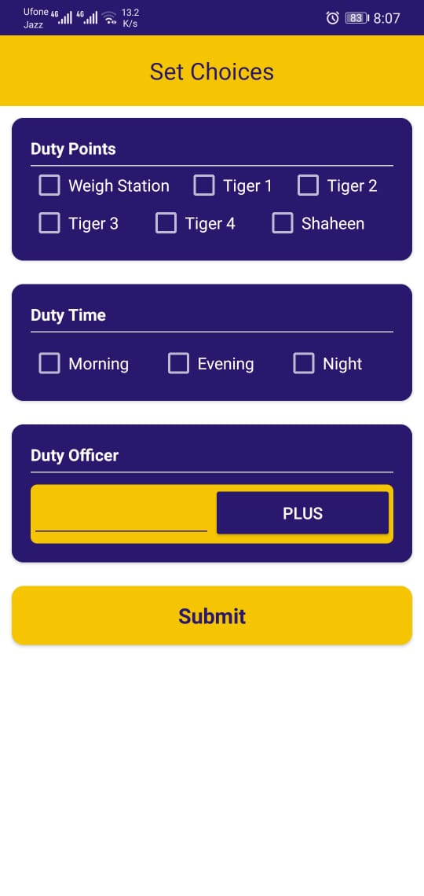

Figure 5. 17 set choices b

### Leaves

When officer click on this then system will tell about all the leaves and its record.

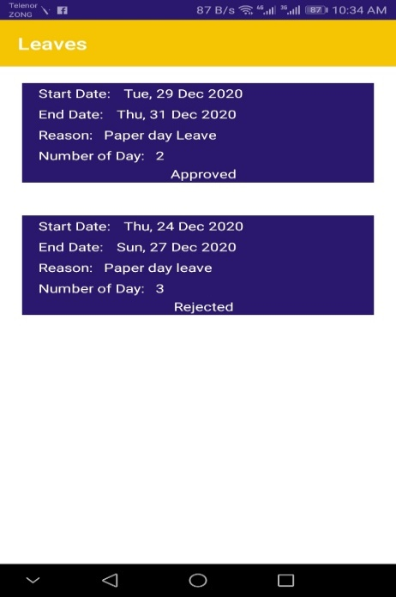

Figure 5. 18 leaveS

### Drawer Panel

Figure 5.19 shows the drawer list. From drawer list user can change password, check profile and user can easily access logout option from drawer list.

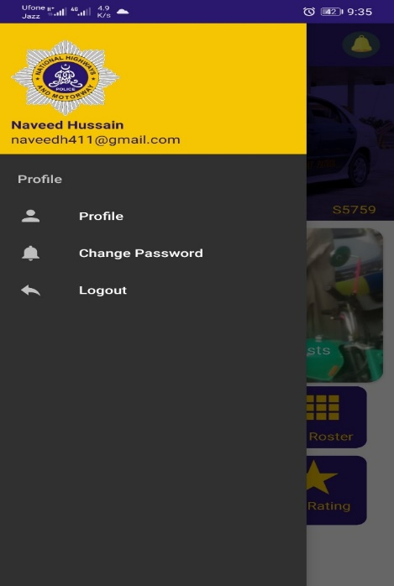

Figure 5. 19 drawer list

### Forgot Password

Figure 5.20 shows forgot password screen. If user forget their password for login they can change password from here easily and again access their activities.

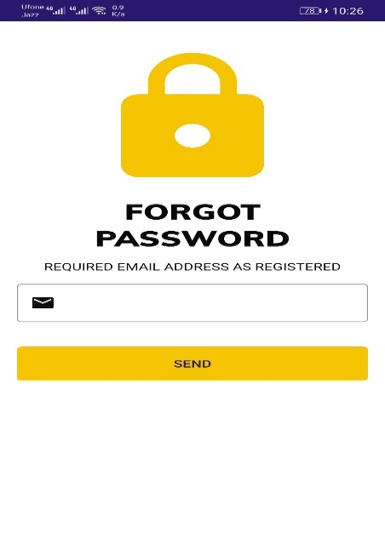

Figure 5. 20 Forgot password

### Leave request

In figure 5.21 officer can add leave. In add leave also add start date and end date with the number of days.

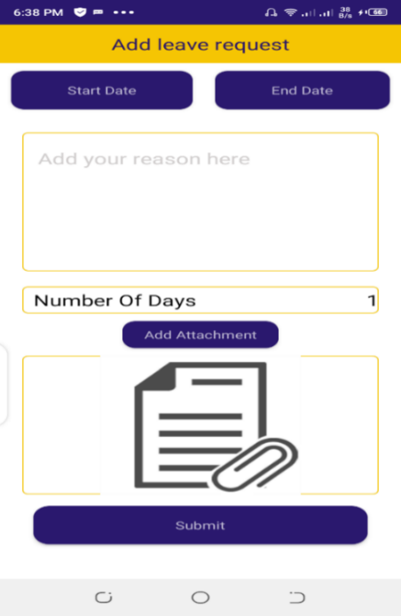

Figure 5. 21 Leave request

### View Duty Roster

Figure 5.22 shows the view duty roster screen. When click view duty roster the generate duty roster will run and algorithm hence assigning new duties.

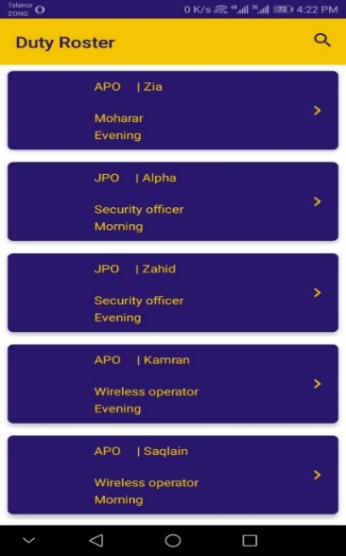

Figure 5. 22 view duty roster

**Chapter 6**

**Evaluation**

# Evaluation

Evaluation is used to check either project meets its aims or not. After the compilation of project, testing is applied on it to check progress. After evaluation developer can claim that project is error free. Evaluation is beneficial for project current progress and for its future work also.

## Testing

Testing is defined as any tool that can reassure the quality and the standard of the product, system and capacity of any application. The testing phase involves the testing of the developed system using various kinds of data. We applied multiple constraints on application and by testing we are assured if all constraints are working or not. Testing should be carried out throughout the entire cycle.

## **Basic Foundation of Testing**

There are two basic foundations of testing.

### Black Box Testing

It is referred to as functional examining. Black box testing is a technique, which checks the internal mechanism of the system and creates the output-generated results. In other words, it focuses on general results of the system. It is often used for validation.

### White Box Testing

White box testing is also referred to as structural testing and glass box testing. On contrary to the black box testing, this testing examines the mechanism of the system. It is often used for verification.

## **Types of Testing**

### Unit Testing

Unit testing lies under the category of white box testing, in unit testing the tester examines the single unit or group of similar units. The tester uses the unit testing to examine whether the units chosen produce the expected result or not. The modules which are used in our application are tested and are working correctly.

### Integration Testing

The testing is applied after unit testing when all units are tested. In integration testing the components or modules are combined for testing and then tests are applied. This testing may lie under black box and white box testing.

### System Testing

System testing is applied by placing the entire system completely in the different environment to check whether it still works or not. It lies under the category of black box testing. In short it examines the whole system.

## **Test Cases**

Different test cases are applied to check the functionality of the project. We provide inputs to the system in the form of test cases and then measure its performance.

### Login Testing

**Scenario**: login

**Application name**: Duty roster for NHMP

Table 6. 1 logout testing

|  |  |  |  |
| --- | --- | --- | --- |
| **Test case** | **Expected result** | **Actual result** | **Pass/fail** |
| Enter null E mail & password | It should not get login | All fields are required | Pass |
| Enter correct login credentials | Login successful | Successfully logged in | Pass |

### Forgot Password Testing

**Scenario:** Forgot password/Reset password

**Application name:** Duty roster for NHMP

Table 6. 2 forgot password testing

|  |  |  |  |
| --- | --- | --- | --- |
| **Test case** | **Expected result** | **Actual result** | **Pass/fail** |
| Click on forget password | Email address for password recovery | Password recovery | Pass |
| Enter email address | Change password | Change password | Pass |

### 

### Add Officer Testing

**Scenario:** Add officer

**Application name:** Duty roster for NHMP

Table 6. 3 add ofiicer testing

|  |  |  |  |
| --- | --- | --- | --- |
| **Test case** | **Expected result** | **Actual result** | **Pass/fail** |
| All fields null | User should not add | Required First Name | Pass |
| Enter first Name | User should not add | Required last name | Pass |
| Enter Last name | User should not add | Required e-mail | Pass |
| Enter wrong CNIC | User should not add | Required 13 digit CNIC | Pass |
| Enter wrong p.no | User should not add | Required 11 digit number | Pass |
| Enter correct credentials | User should add | Add officer | Pass |

### Add Rating testing

**Scenario:** Add rating

**Application name:** Duty roster for NHMP

Table 6. 4 add rating testing

|  |  |  |  |
| --- | --- | --- | --- |
| **Test case** | **Expected result** | **Actual result** | **Pass/fail** |
| Enter no data | Should not submit | Not submit | Pass |
| Enter data in just one fields | Should not submit | Not submit | Pass |
| Fill all fields with correct credentials | Should submit | Submit | Pass |

### 

### Set Choices testing

**Scenario:** Set choices

**Application name:** Duty roster for NHMP

Table 6. 5 Set choices testing

|  |  |  |  |
| --- | --- | --- | --- |
| **Test case** | **Expected result** | **Actual result** | **Pass/fail** |
| Null fields | Should not submit | Not submit | Pass |
| Enter data in just one field | Should not submit | Not submit | Pass |
| Enter correct data in all fields | Should submit | Submit | Pass |

### 

### Add leave request testing

**Scenario:** Add leave request

**Application name:** Duty roster for NHMP

Table 6. 6 Add leave request testing

|  |  |  |  |
| --- | --- | --- | --- |
| **Test case** | **Expected result** | **Actual result** | **Pass/fail** |
| Null fields | Should not submit | Not submit | Pass |
| Enter correct credentials | Should submit | Submit | Pass |

### Logout Testing

**Scenario:** logout

**Application name:** Duty roster for NHMP

Table 6. 7 Logout testing

|  |  |  |  |
| --- | --- | --- | --- |
| Test case | Expected result | Actual result | Pass/fail |
| Logout | Session should destroy | Session expire | Pass |

**Chapter 7**

**Conclusion**

# Conclusion

We have created an application named as “Duty Roster for NHMP”. In this project we learn the use of android studio and how to connect different activities to each other and connection with firebase database. In our application we added many features. In this app officers (users) will get an interface where they can have an option like duty shift, area, and a list of friend officers. And add other features like supervisor admin (Admin officer) can also deduct the ratings due to any misconduct that will affect his score (rating) negatively.

## Future work

In future, we can further improve our application through several ways like:

* We will cover all beats under jurisdiction of NHMP.
* The database of E-ticketing will be connected to enter the score of officers.
* More interactive way of communication like chat, and detailed news feed.

## References

1. <https://play.google.com/store/apps/details?id=com.papershiftlocationapp.android.plan&hl=en_US>
2. <https://play.google.com/store/apps/details?id=com.lorenzen.u8soccerroster&hl=en_GB>
3. <https://play.google.com/store/apps/details?id=org.planmyshift.planmyshift&hl=en_GB>
4. <http://www.islamabadtrafficpolice.gov.pk/violation-and-fine.php>
5. <https://www.youtube.com/playlist?list=PL1q3ROAofjeOUwh7lPBnGbg__DUodwLN7>
6. <https://www.encyclopedia.com/law/encyclopedias-almanacs-transcripts-and-maps/traffic-violations>
7. <https://7esl.com/vehicles-vocabulary/>
8. <https://www.youtube.com/watch?v=2MYgZQjX7N0>
9. <https://developer.android.com/studio/write/firebase>
10. <https://www.punjabpolice.gov.pk/trafficpolice>
11. <https://concepts.app/en/ios/manual/pdf>
12. <https://www.youtube.com/watch?v=zid-MVo7M-E>
13. <https://www.psca.gop.pk/EChallan/Index>